Application Form for Computer Scoring,
Division of curricular affairs of the Office of Academic Affairs (March 13, 2009)
1. Instructors who teach common required courses and general education courses are welcome to use the blank scantron answer sheets and the card reader scoring service offered by Division of curricular affairs.
2. Instructors should read the "Regulations for Setting Computer Scoring Exams" carefully before setting the paper. (please read P.2 carefully)
3. The card reader is available from 8:30 to 17:00 on weekdays. Please book the card reader in advance. Please call 3366-2388 or fax 2362-6282.
4. The application process for computer scoring is as follows:
Table 1
Please collect the answer sheets and grade reports immediately after scoring.

1. Submit the application form to Division of Curricular Affairs and get the blank answer sheets.
2. Book your time for the card reader (via phone or fax).

Submit the standard answer sheets, answer sheets to be scored, and the computer scoring item type distribution table to Division of Curricular Affairs.

Computer scoring (about half an hour)

Download and fill out the application form from Division of Curricular Affairs' website.

Course Title: |  | General Education Course □  Common Required Course □ |  | Instructor:  Department:
Contact Information: | Name: Mobile phone: Phone: Email:
Curriculum Number: | Class: |  | Number of students: | Number of required answer sheets:  Date:
Instructor's signature: |  |  | Recipient: | Issuer:

Table 2
Reservation for card reader: (Y) (M) (D) Time: (about half hour per course)
Applicant: Case Officer:
Instructor collects _ answer sheets and prints _ grade report(s) after scoring.
Soft copy: yes□ no□ Recipient: Case Officer:

Division of curricular affairs of the Office of Academic Affairs
Phone: 3366-2388 ext. 308 Fax: 2362-6282

Form download: http://curri.aca.ntu.edu.tw/cur2007/genform/excardap.doc

Regulations for Setting Computer Scoring Exams (March 13, 2009)
1. Each answer sheet has up to 100 items, including multiple choice, multiple selection, and multiple answer items. Instructors can arrange item types (7 items at most) in random order, or decide whether to subtract a fraction of a point for wrong answers.
2. Explanation of Item Types:
[Type 1: Multiple choice] Each item has only one correct answer. Points are given only if the student's answer is consistent with the standard answer.
[Type 2: Multiple selection] Each item has two correct answers. Points are given only if the student's answer is consistent with the standard answer.
[Type 3: Multiple answer] Answers are scored according to the number of choices listed for each question. For example, if a question has 5 choices ABCDE, a student scores 5 points if the answer is correct and 0.5 point will be subtracted for each wrong choice. Therefore, if the standard answer is ABC and the student's answer is ABCD, the question will be given 3.5 points. (5*1/5)＋(5*1/5)＋(5*1/5)－0.5＋(5*1/5)＝3.5
3. Before using the card reader, instructors should provide an answer sheet with standard answers (with indication of course title, class, department, and instructor's name), and an item type distribution table for the computer's reference. The standard answer sheet, item type distribution table and answer sheets to be scored should be submitted to Division of curricular affairs (Administration Building, room 208) at the appointed time. Please retrieve the answer sheets and grade reports the same day after scoring. Division of curricular affairs will not hold custodial responsibility.
Computer Scoring Item Type Distribution Table
Course Title:  Curriculum Number and Class: |  |  |  | Instructor: Department:
Test Item | Item Type (1,2,3) | Number of Item (first - last) | Points for each item |  | point subtraction for wrong answers (points to be subtracted/ points for the item) | Total score:
 |  | - |  |  | /
 |  | - |  |  | /
 |  | - |  |  | /
 |  | - |  |  | /
 |  | - |  |  | /

Example of Grade Report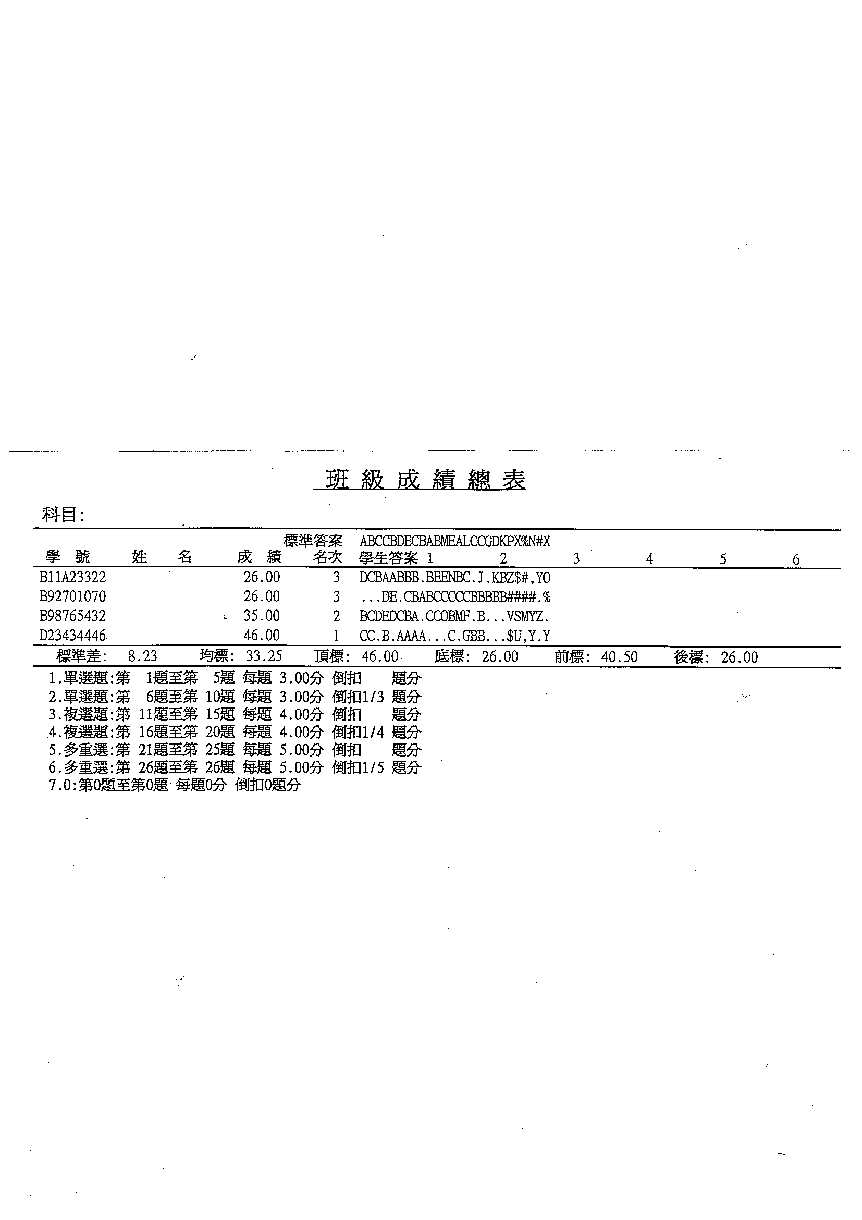
National Taiwan University Division of curricular affairs of the Office of Academic Affairs
Phone: 3366-2388 Fax: 2362-6282
Form Download: http://curri.aca.ntu.edu.tw/cur2007/forms.htm/excardap.doc

