NTU Teaching and Research
Unit Evaluation

Evaluator Manual

Contents

i. A Letter to Evaluators 3
ii. Legal Basis 5
iii. Evaluation Procedures 7
iv. Job Duties for Evaluators 21
v. Supporting Materials and Forms for Evaluators 25
vi. Functions and Operation of the Online System of Performance Evaluation for Teaching and Research Units (Online Evaluation System) 27
vii. Accommodation and Traffic Access 30
Appendix I—NATIONAL TAIWAN UNIVERSITY Regulations for Evaluation of Teaching and Research Units 31

- A Letter to Evaluators

Dear evaluators,
Thank you for serving on a teaching and research unit evaluation committee for National Taiwan University (hereinafter “NTU”). We would like to express our sincere gratitude and appreciation to you.
In the interest of bolstering self-improvement, NTU has conducted campus-wide evaluations of teaching and research units since the 1997 Academic Year. We at NTU developed the “Evaluation Guidelines for Teaching and Research Units” (hereinafter the “Guidelines”), which serve as the official rules governing this quinquennial practice termed ‘self-evaluation of teaching and research units.’ Since the project’s inception, each unit being evaluated has undergone four cycles of evaluation. During this process, we at NTU have been enhancing the evaluation system and building a well-established culture thereof. The results of performance evaluations and related suggestions also serve as a constructive reference whereby both the units under evaluation and the university can improve their development and academic activities.
To this end, we have prepared this “Evaluator Manual” based on the Guidelines and the annual evaluation of teaching and research units. We also made an introductory video named “Evaluation for Teaching and Research Units, Regulations & Procedures.” The manual and the introductory video are intended to familiarize evaluators with NTU’s evaluation system, as well as the procedures and schedules thereof.
Despite our efforts to make this manual and the video as explicit and comprehensive as possible, we hope that all users can provide feedback for us to make corrections.
*Introductory Video: https://ppt.cc/fHjrAx
*Evaluation Page: https://ppt.cc/fs640x
*Contact:
Unit under evaluation: (insert the contact of the unit under evaluation)
Office of Academic Affairs: person in charge of evaluation for teaching and research units
+886-2-3366-2388 (EXT. 105, Hong-Sheng, Chen, Executive Officer)
Email: seanchen0706@ntu.edu.tw
- Legal Basis

The history and structure of NTU’s evaluation guidelines:
Over 20 years have passed since the system for evaluating the performance of teaching and research units at NTU was introduced in 1997. In that year, the Guidelines were developed during the second semester of the 1996 Academic Year (which was in the calendar year of 1997). As the legal basis for performance evaluation of teaching and research units at NTU, the guidelines have been amended thirteen times. These amendments were made to facilitate evaluation procedures and conform to the current trends, in compliance with applicable laws and regulations. As such, these units may offer guaranteed quality of courses and research in order to foster the well-balanced development of the university.
The following shows the purposes of the articles under the Guidelines.

Table 2-1. Purposes of the Articles under the Guidelines
Item | Purpose
Article 1 | Rationale
Article 2 | Scope
Article 3 | Level 3 Evaluation Committee
Article 4 | Oversight Committee of Evaluation of University
Article 5 | Oversight Committee of Evaluation of Colleges
Article 6 | Evaluation Committees for Units under Evaluation
Article 7 | Task Forces
Article 8 | Workshops on Evaluation
Article 9 | Cycles of Evaluation (quinquennial, i.e. once every five years as a cycle)
Article 10 | Evaluation Items
Article 11 & 12 | Procedures and Schedules
Article 13 | Evaluation Criteria for Colleges
Article 14 | Classification of Evaluation Results
Article 15 | Appeal
Article 16 | Application and Guidelines for Joint Evaluation
Article 17 | Application of Evaluation Results
Article 18 | Presentation of Evaluation Results
Article 19 | Source of Financial Support
Article 20 | Handling of Matters Not Provided Herein
Article 21 | Procedures for Enforcement and Amendment

- Evaluation Procedures

The procedures for evaluating the performance of teaching and research units at NTU are set out in Article 11 of the Guidelines. The workflows and schedules are shown in Figure 3-1 and Table 3-1. Procedures relevant to evaluators are indicated by the asterisk (*).

Figure 3-1. Procedures for Performance Evaluations
Procedures relevant to evaluators are indicated by the asterisk (*).
Month | Workflow
June | The Office of Academic Affairs shall investigate which units are to be evaluated.
↓
August | The Office of Academic Affairs shall convene the first meeting of the Oversight Committee of Evaluation of University and determine which units are to be evaluated and the evaluation procedures.
↓
September | The heads of the highest managing units shall submit a list of recommended evaluators for their subordinate units under evaluation to the Office of Academic Affairs for compilation.
↓
October | The Office of Academic Affairs shall convene the second meeting of the Oversight Committee of Evaluation of University, where the list of recommended evaluators and the payment criteria for evaluation fees will be determined.
↓
＊November | Each unit under evaluation shall, upon obtaining the consent of evaluators, submit a list of evaluators to be appointed and the signed “Conflict of Interest Agreements for Evaluators” to the Office of Academic Affairs, which will prepare their certificates of appointment.
↓
Next January | The Office of Academic Affairs shall inform each unit to be evaluated about the subsidies available to them, and the corresponding budget codes.
↓
＊1 month prior to site visit | Each unit under evaluation shall send the certificate of appointment, the Evaluator Manual, and the Written Review Comments on the Self-Evaluation Report & Replies from the Unit under Evaluation to each evaluator. Site visits shall be conducted as scheduled.
↓
＊1 week prior to site visit | Evaluators shall provide their respective units under evaluation with a completed copy of the Written Review Comments on the Self-Evaluation Report. These units shall reply to the evaluators before the first day of the site visit.
↓
＊Within 30 days upon site visit | Evaluators shall submit the Final Evaluation Report to the Oversight Committee of Evaluation of Colleges for reference.
↓
＊Within 14 days since the next day of receiving the Final Evaluation Report | A unit under evaluation intending to lodge an appeal according to Article 15 of the Guidelines should fill in the appeal form and submit it with specific supporting materials to Office of Academic Affairs, who shall send the form and supporting materials to the evaluation committee for review and direct the committee to notify the evaluated unit about their replies.
↓
Within 30 days upon presentation of the Final Evaluation Report | Each unit under evaluation shall submit a completed copy of the Review Comments & Improvement Plans to the Oversight Committee of Evaluation of Colleges for review.
↓
Next August | - The unit under evaluation shall submit the Final Evaluation Report to the Oversight Committee of Evaluation of College for reference. After the said documents are approved, the evaluated unit and its college shall upload respectively the report along with its summary and the reference comments by the Committee to the online evaluation system.  - The unit under evaluation shall submit the Review Comments & Improvement Plans to the Oversight Committee of Evaluation of College for review. After the said documents are reviewed, the evaluated unit and its college shall upload respectively the Review Comments & Improvement Plans along with its summary and the review comments by the Committee to the online evaluation system.
↓
Next September | The Office of Academic Affairs shall coordinate plans to address the issues proposed by NTU with the highest managing units.
↓
Next October | The Office of Academic Affairs shall compile the Final Evaluation Report, a summary of the Review Comments & Improvement Plans, and the reference/review comments by the Oversight Committee of Evaluation of College into an electronic manual, which will be submitted to the Oversight Committee of Evaluation of University and related parties.
↓
Within 1 year upon site visit | Each unit under evaluation shall submit the Final Report on Improvement Measures Taken to the Oversight Committee of Evaluation of College for review. After the said report has been reviewed, the unit under evaluation and its college shall upload it, along with a review summary, to the online evaluation system for the Oversight Committee of Evaluation of University for review and for related parties for reference (The year after next October).

Table 3-1. Evaluation Schedule
Procedures relevant to evaluators are indicated by the asterisk (*).
Time (year/month) | Events | Requirements | Forms
June 2023 | The Office of Academic Affairs shall confirm the planned evaluation with the units to be evaluated for the next academic year via mail. | Each unit to be evaluated shall inform the Office of Academic Affairs about its willingness to undergo the evaluation, or apply for joint/early/extended evaluation by submitting supporting documents. | Each unit to be evaluated shall confirm the Confirmation Sheet for Evaluation Schedule
August 2023 | - The Oversight Committee of Evaluation of University shall convene the 1st meeting to discuss the annual evaluation, including details of the planned evaluation and which units are to be evaluated. The Office of Academic Affairs shall send a copy of the meeting minutes to the units to be evaluated and their respective colleges.  - The Office of Academic Affairs shall direct the units to be evaluated to prepare for the evaluation procedures as scheduled and send applicable forms to them.  - The Office of Academic Affairs shall direct the dean of each college, the Vice President for Academic Affairs or the Executive Vice President for Academics and Research to confirm the list of recommended evaluators proposed by each unit to be evaluated. The evaluators for Level 1 research centers shall be nominated by the Vice President for Academics and Research. The evaluators for Level 1 teaching units shall be nominated by the Vice President for Academic Affairs. The evaluators for Level 2 units shall be nominated by the head of the highest managing unit.  - With regard to applications for joint/early/extended evaluation, the Office of Academic Affairs shall notify the unit to be evaluated about the results of review of such applications by the Oversight Committee of Evaluation of University. | - Each unit to be evaluated shall confirm the results regarding the normal/joint/early/extended evaluation.  - Each unit to be evaluated shall prepare for evaluation as per the approved Evaluation Schedule.  - Each unit to be evaluated shall send a list of recommended evaluators to the dean of each college, the Vice President for Academic Affairs or the Executive Vice President for Academics and Research for confirmation. Each unit to be evaluated shall then send the confirmed list to the Office of Academic Affairs for compilation for approval by the Oversight Committee of University of Evaluation. | Evaluation Schedule; List of Recommended Evaluators (blank)
October 2023 | - The Oversight Committee of Evaluation of University shall convene the 2nd meeting to determine the convener of the evaluation committees for the units to be evaluated, the list of evaluators, and the payment criteria for evaluation fees.  - The Office of Academic Affairs shall direct the Personnel Department, the Office of Research and Development, the Undergraduate Academic Affairs Division, the Curriculum Division, and the Graduate Academic Affairs Division to update the data in the Self-evaluation Reports (Tables 2-1, 2-2, 4-6, 4-7 and 4-8).
November 2023 | - The Office of Academic Affairs shall officially notify the units to be evaluated and their respective colleges about the aforesaid meeting minutes. This shall include the approved list of recommended evaluators, payment criteria for evaluation fees, list of evaluators to be appointed, and evaluation schedule as well as related instructions.  - The Office of Academic Affairs shall notify each unit under evaluation about the updated data in the Self-evaluation Report for the 2022 Academic Year (including Tables 2-1, 2-2, 4-6, 4-7 and 4-8), and update the online versions on the website dedicated to performance evaluation simultaneously.  - The Office of Academic Affairs shall propose a program on training staff members working for the performance evaluations for the 2022 Academic Year. Once the program is approved, the Office of Academic Affairs shall organize workshops to train staff members working for the evaluations of teaching and research units. (between November, 2023 and February, 2024) | - With regard to the list of recommended evaluators, each unit to be evaluated shall confirm the results of review by the Oversight Committee of Evaluation of University, and go through the appointment procedures based on the list. Each unit to be evaluated shall also have the evaluator to be appointed sign the “Conflict of Interest Agreement for Evaluators.”  - Each unit under evaluation shall make updates based on relevant data about the Self-evaluation Report provided by the Office of Academic Affairs.  - The units to be evaluated shall send representatives to take part in related workshops. | “Conflict of Interest Agreement for Evaluators”; Self-evaluation Report
December 2023 | - The approved lists of evaluators to be appointed shall be compiled, and the Chinese- and English-language versions of their certificates of appointment shall be prepared.  - The Office of Academic Affairs shall estimate the amount of subsidies offered by NTU. The calculation shall be made based on the number of evaluators to be appointed, travel distances, and the number of days of site visits.  - The Office of Academic Affairs shall direct the President to approve the budget regarding the subsidies for each unit to be evaluated for the 2023 Academic Year.  - The Office of Academic Affairs shall have prepared the Chinese- and English-language versions of certificates of appointment, and sent them to each unit to be evaluated, which shall pass on these documents to the evaluators. | - The units to be evaluated shall notify the Office of Academic Affairs about the evaluator lists approved by respective colleges or the heads of the managing units. The signed Conflict of Interest Agreements for Evaluators shall also be compiled and passed on to the Office of Academic Affairs.  - Each unit to be evaluated shall confirm the content of the Chinese- and English-language versions of the certificates of appointment, and issue them to evaluators. | The list of evaluators to be appointed; Conflict of Interest Agreement for Evaluators
January 2024 | The Office of Academic Affairs shall officially inform each unit to be evaluated for the 2023 Academic Year about the subsidies available, and the corresponding budget codes. | The units to be evaluated shall confirm the subsidies available to them offered by NTU.
By May 2024  (1 month prior to the site visit) |  | - Each unit under evaluation shall complete the Self-Evaluation Report within 30 days prior to the site visit. Upon being approved by the head of the managing unit, the report shall be submitted, along with the Certificate of Appointment, the Evaluator Manual, and the Written Review Comments on the Self-Evaluation Report & Replies from the Unit under Evaluation, to each evaluator.  - In addition, the Self-Evaluation Report shall be submitted to five supervisors (i.e. the President, the Executive Vice President for Academics and Research, the Executive Vice President for Administrative Affairs, the President for Academic Affairs, and the President for Research and Development) for review. | Self-Evaluation Report
* By June 2024 | The Office of Academic Affairs shall direct the units under evaluation to notify their respective evaluators to complete the Final Evaluation Report within 30 days upon the site visit. | 1. The units under evaluation shall direct their respective evaluators to complete and return the Written Review Comments on the Self-Evaluation Report & Replies from the Unit under Evaluation to them within one week prior to the site visit. The units under evaluation shall respond to the comments from the evaluators before the first day of the site visit.  2. The units under evaluation and their respective evaluation committees shall finish the site visit before June 30. The evaluators shall present an oral summary of the evaluation results during the end-of-visit meeting on the last day of site visit. | Written Review Comments on the Self-Evaluation Report & Replies from the Unit under Evaluation
* July 2024  (within 30 days after the site visit) | The completed report shall be submitted to the Oversight Committee of Evaluation of Colleges for reference. Upon being reviewed, the report shall be uploaded, along with a reference summary, to the online evaluation system. The Office of Academic Affairs shall compile and pass on all relevant documents to the Oversight Committee of Evaluation of University for reference. | 1. Each unit under evaluation shall complete the Final Evaluation Report within 30 days upon the site visit according to the format required by the Office of Academic Affairs. The beginning of the report shall include a summary of the evaluation results.  2. The units under evaluation shall submit the Final Evaluation Report to the Oversight Committee of Evaluation of Colleges for reference. The referenced documents shall be uploaded to the online evaluation system. | Final Evaluation Report
*Within 14 days since the day after receiving the Final Evaluation Report | Lodge an appeal (if necessary) | A unit under evaluation intending to file an appeal should fill out the appeal form and submit it with specific supporting materials to the Office of Academic Affairs within 14 days since the day after receiving the evaluation result. A late submission will not be accepted and each unit can only file an appeal once. The Office of Academic Affairs shall send the appeal form and supporting materials to the evaluation committee for review and direct the committee to notify the evaluated unit about their replies. | Appeal Form for Teaching and Research Units Evaluation
August 2024 | The Office of Academic Affairs shall direct the units under evaluation to complete the Written Review Comments on the Self-Evaluation Report & Replies from the Unit under Evaluation by late August, and submit the form to the Oversight Committee of Evaluation of Colleges for review. Upon being reviewed, the report shall be uploaded, along with a review summary, to the online evaluation system. The Office of Academic Affairs shall compile and pass on all relevant documents to the Oversight Committee of Evaluation of University for reference. | Before the end of August, each unit under evaluation shall complete the Review Comments & Improvement Plans by late August and submit the form to the Oversight Committee of Evaluation of Colleges for review. Upon being reviewed, the report itself and its summary and the review comments shall be separately uploaded by the unit under evaluation and its respective college to the online evaluation system. | Review Comments & Improvement Plans
September 2024 | The Office of Academic Affairs shall direct related parties to convene a campus-wide coordination meeting to help the units under evaluation resolve problems and propose improvement measures. | Each unit under evaluation shall send representatives to take part in the coordination meeting with related parties, and solve problems or discuss the improvement measures to be taken.
October 2024 | - The Office of Academic Affairs shall compile the Final Evaluation Report, and the Review Comments & Improvement Plans from each unit under evaluation for the 2023 Academic Year. Upon being compiled, the documents shall be submitted to the Oversight Committee of Evaluation of University to be discussed at the 2nd committee meeting for the 2024 Academic Year.  - The Office of Academic Affairs shall prepare a List of Evaluation Results, and obtain the approval from the President before publishing it on the homepage of the NTU website, and the page dedicated to performance evaluations on the website of the Office of Academic Affairs.
April 2025 | The Office of Academic Affairs shall direct each unit under evaluation to complete the Final Report on Improvement Measures Taken for the 2023 Academic Year, and submit the completed report to the Oversight Committee of Evaluation of Colleges for review. Upon being reviewed, the said report itself and its summary and the review comments shall be separately uploaded by the unit under evaluation and its respective college to the online evaluation system. Then the Office of Academic Affairs will pass on all relevant documents to the Oversight Committee of Evaluation of University for reference and to related parties for reference.
By June 2025 |  | Each unit under evaluation shall submit a completed copy of the Final Report on Improvement Measures Taken to the Oversight Committee of Evaluation of Colleges for review. Upon being reviewed, the said report itself and its summary and the review comments shall be separately uploaded by the unit under evaluation and its respective college to the online evaluation system. | Final Report on Improvement Measures Taken
October 2025 | The Office of Academic Affairs shall submit the compiled Final Report on Improvement Measures Taken of each unit under evaluation for the 2023 Academic Year to the Oversight Committee of Evaluation of University to be discussed at the 2nd committee meeting for the 2025 Academic Year.

- Job Duties for Evaluators
  - Preliminary Review:
      - Self-evaluation Report: Each unit under evaluation will send a Self-evaluation Report, along with a Preliminary Review Comments form, 30 days before the site visit to evaluators for prior written review.
      - Returning the Preliminary Review Comments form: Evaluators shall fill out the form detailing suggestions and questions and return it to their respective units under evaluation within one week prior to the site visit. These units shall answer the questions from the preliminary review during the site visit.
  - Site visit:
- Each unit under evaluation will arrange a site visit (1 to 2 days as the principle). Evaluators are advised to reserve time in advance for full participation.
- The schedule for a site visit usually includes the following:
(1) Introduction to the college and its subordinate unit under evaluation
(2) A tour of teaching and research facilities (including software and hardware) and a review of relevant materials
(3) A meeting with the students, faculty members and head of the unit being evaluated
(4) A session for evaluators to ask questions for clarification
(5) A panel discussion, during which the unit will answer questions for clarification
(6) A session for holding an evaluation committee meeting, where the evaluators shall present an oral summary of the evaluation results and prepare a (draft) evaluation report
- For details, please refer to the schedule provided by the unit under evaluation.
  - Final evaluation report:
- Final Evaluation Report: Evaluators shall prepare a Final Evaluation Report detailing comments on the site visit, according to the NTU format. Evaluators shall then return both hard copy and soft copy of the report (finalized version) to NTU within 30 days upon the site visit.
- There are two versions of Final Evaluation Report. One is for “Departments/Graduate Institutes/Degree Programs”; the other is for “Colleges/Research Centers.” Please choose the applicable one according to the unit under evaluation.
      - NTU’s Final Evaluation Report for Departments/Graduate Institutes/Degree Programs -
This version is divided into two parts: “Evaluation Checklist” and “Evaluation Summary Report.” For the Evaluation Checklist, evaluators shall mark the unit under evaluation based on the items under the four evaluative criteria: teaching, research, service, and administration. A four-level grading system is adopted: Excellent, Very Good, Good, and Fair. Evaluators shall thoroughly consider the unit’s performance according to the four criteria before marking the unit as “pass,” “conditional pass,” or “fail” as its final evaluation result. The second part is Evaluation Summary Report. Evaluators shall provide their comments according to the format required.
      - NTU’s Final Evaluation Report for Colleges/Research Centers- This version is divided into seven sections. Evaluators shall organize their comments according to the format required.
- Writing Style:
(1) For the sake of clarity, evaluators shall maintain a consistent writing style for the Final Evaluation Report as per the NTU format, and avoid writing the report in a mixture of Chinese and English.
(2) Evaluators shall include a summary of the evaluation results at the beginning of the report.

  - Procedures for lodging an appeal:
    - The unit under evaluation may lodge an appeal within 14 days after the date the unit receives the Final Evaluation Report if the unit considers the evaluation result of “Conditional pass” or “Fail” is due to one of the following facts:
      - The evaluators violated the regulated procedures during the site visit.
      - The data, materials, or other written records in the Final Evaluation Report are inconsistent with actual situations.
    - When the unit under evaluation files an appeal, the Office of Academic Affairs shall send the appeal form and supporting materials to the evaluation committee for review and direct the committee to notify the evaluated unit about their replies.
    - If the unit under evaluation is still not satisfied with the evaluators’ replies, the unit shall direct the Office of Academic Affairs to pass on the appeal documents to the Oversight Committee of Evaluation of University for discussion (within 14 days upon receiving the replies). The Office of Academic Affairs shall then notify the unit about the final result officially. In addition, the representatives of the unit under evaluation may attend the meeting of the Oversight Committee of Evaluation of University for clarification.
  - Resources and links:
- For further information on performance evaluations of teaching and research units at NTU (including regulations, rationale, units to be evaluated, procedures and application status, please visit the Evaluation of NTU Academic Units website, which is maintained by the Office of Academic Affairs.
(https://ppt.cc/fs640x ; NTU homepageAdministration Office of Academic AffairsSecretariatServices Evaluation of NTU Academic Units)
- For more information on evaluation-related workshops and education programs launched by NTU, please also visit the website above related presentation materials.
- If you have any other questions or suggestions about traffic access, accommodation, expense reimbursement, forms, etc., please feel free to contact the following personnel:

Unit under evaluation: _________ (insert the contact of the unit under evaluation)
Office of Academic Affairs: Hong-Sheng, Chen, Executive Officer
Tel: +886-2-3366-2388 ext. 105
Email:seanchen0706@ntu.edu.tw

- Supporting Materials and Forms for Evaluators
Please refer to the following introductory video and links for supporting materials and forms related to the job duties of evaluators. These documents include information on performance evaluations of teaching and research units at NTU, as well as job requirements and schedules thereof. Please also consult the contact person at the unit under evaluation for relevant documents or download from the Evaluation of NTU Academic Units website (https://ppt.cc/fs640x).
  - Introductory Video

The video (“Evaluation for Teaching and Research Units, Regulations & Procedures”) made by NTU intends to assist evaluators to quickly familiarize themselves with the performance evaluation policy of NTU (including the items for evaluation and the schedule). Please watch the video before the site visit at https://ppt.cc/fHjrAx

(A screenshot of the video)
  - Supporting materials
    - Evaluator Manual
    - Evaluation Schedule
    - Payment Criteria for Evaluation Fees (Chinese Version only)
    - Site visit schedule (provided by the unit being evaluated)

  - Forms
    - Written Review Comments on the Self-Evaluation Report & Replies from the Unit under Evaluation
    - Final Evaluation Report
- for departments, graduate institutes and degree programs
- for colleges and research centers

vi. Functions and Operation of the Online System of Performance Evaluation for Teaching and Research Units (Online Evaluation System)

A. Introduction of the Online Evaluation System
1. The system is set up to boost the efficiency of the evaluation procedures, facilitate the exchange of evaluation-related information and improve the management of the evaluation affairs.
2. The functions of the system vary according to the job title of the people involved in the performance evaluation. There are six job titles, including the person in charge (of the unit under evaluation), the evaluators of the unit under evaluation, the staff in charge (in the college-level units), the members of the Oversight Committee of Evaluation of College, the university-level system administrators and the members of the Oversight Committee of Evaluation of University. The following section will only demonstrate the functions and operation of the system for “the evaluators of the unit under evaluation.”

B. The Operation of the Online Evaluation System
1. The Log-in Process:
(1) The units under evaluation shall establish accounts for the evaluators, who shall go to the email boxes provided by the units and check the email of confirmation and appreciation, in which the evaluators shall find their passwords to log in.
(2) Please open the following system URL in the Chrome browser : https://ifweb.aca.ntu.edu.tw/EvaluationUnits
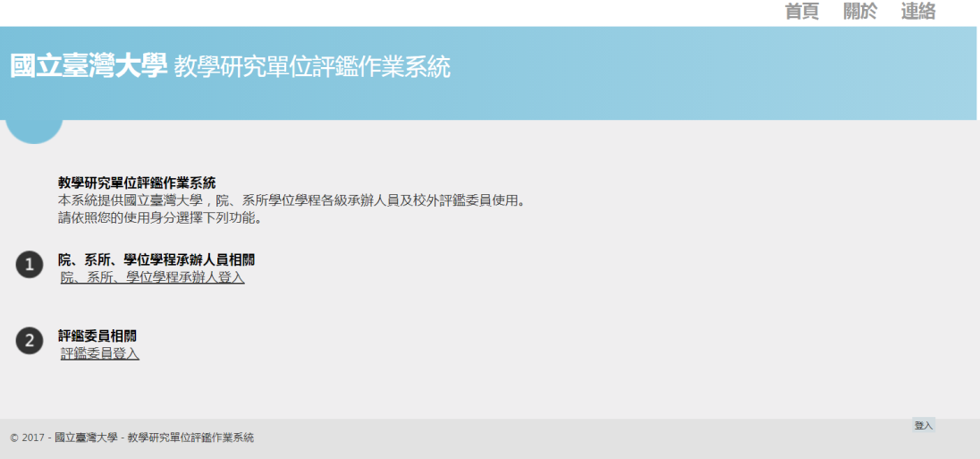
Evaluators log in here
(3) Please enter the username (email address) and password and click “log in.”
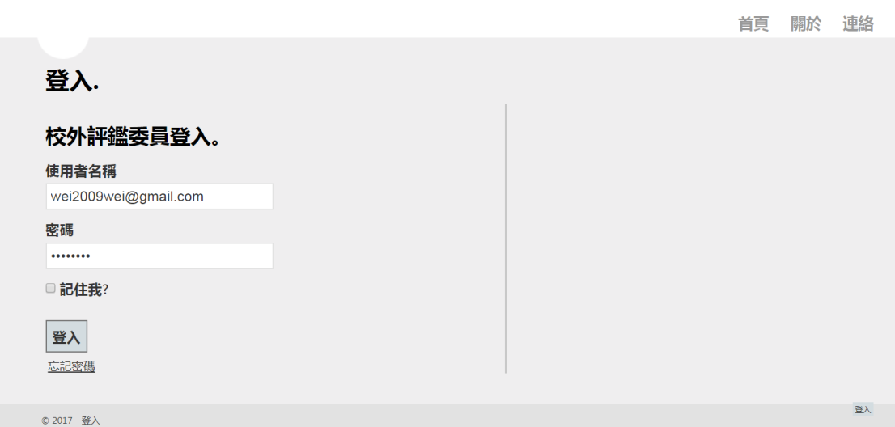
1. Evaluators log in here
2. Press “Forget Password” to reset

(4) If you forget your password, please enter your username and click “Forget Password”. Then reset your password following the instructions of the system.
2. Resetting the password: You will see Set Password when you log in to the system. Then you can set or reset your password by clicking the option.
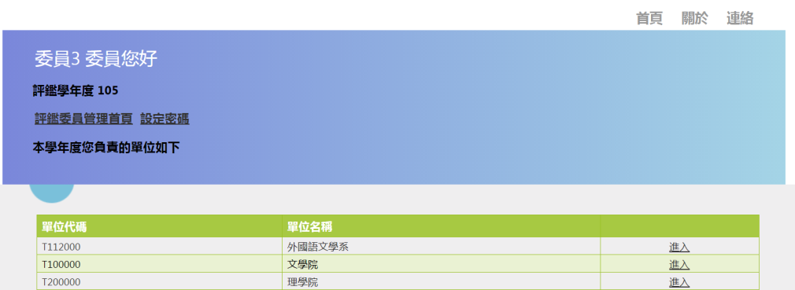
1. Click here to set the password
2. Evaluators with multiple identities may click here to find appropriate pages to enter

3. Switching between multiple identities: If the evaluator is of multiple identities, he or she can enter the pages of different units by clicking on the specific identities shown in the menu after logging in.
4. Downloading and uploading the files: Please follow the instructions on the figure below to download the blank form templates as well as the reports and attachments uploaded by the units under evaluation, and to upload the Written Review Comments and Final Evaluation Reports.
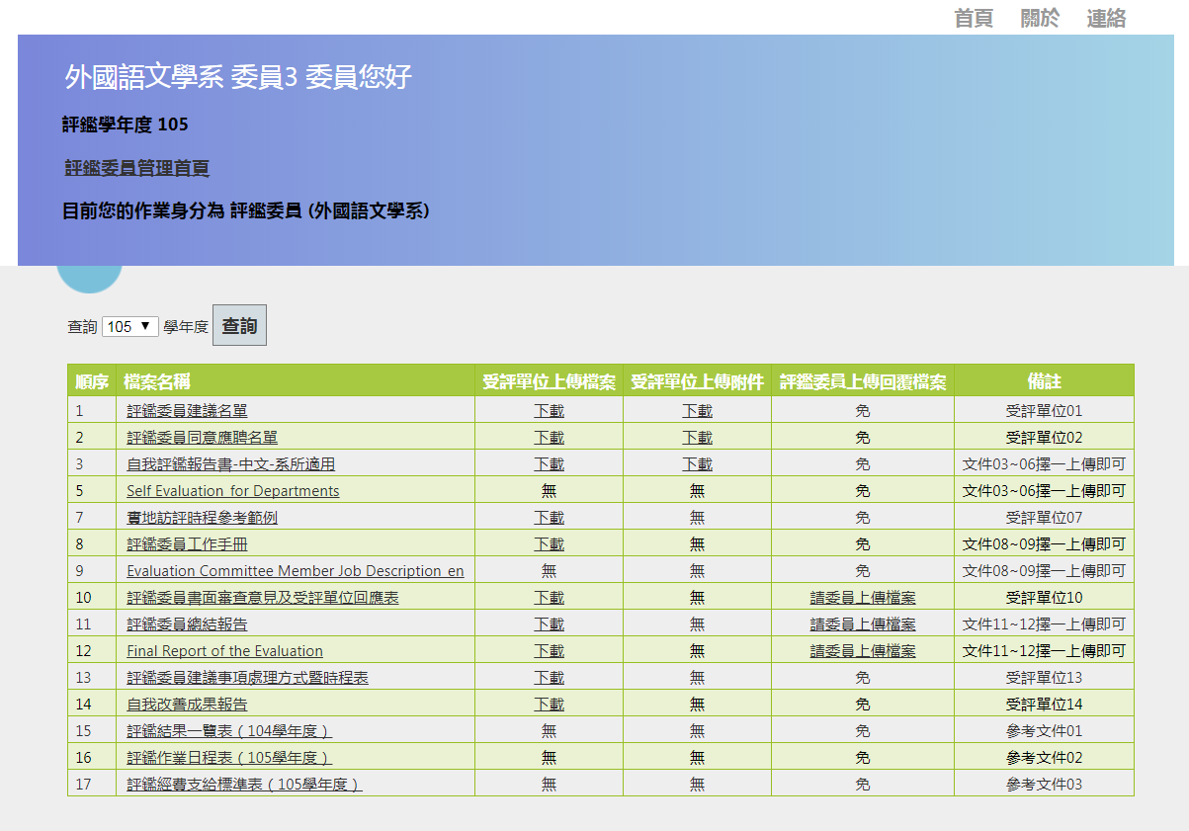
1. Click the filename to download the blank form template.
2. Click Download to download the reports and attachments uploaded by the unit under evaluation.
3. Click Evaluators Upload to upload Written Review Comments and Final Evaluation Report

vii. Accommodation and Traffic Access
        - Accommodation
Each unit under evaluation will arrange accommodation and transportation during the site visit for evaluators visiting NTU for a performance evaluation. Please contact the contact person at the unit under evaluation.
        - Traffic Access
Please refer to the following links for the campus map and traffic access:
Information on traffic access on the homepage of the NTU website: https://www.ntu.edu.tw/about/map.html

NTU campus map:
https://www.ntu.edu.tw/about/map/B_01_A.jpg

NATIONAL TAIWAN UNIVERSITY
Appendix I
Regulations for Evaluation of Teaching and Research Units

June 20, 2023 Passed by the 3,148th Administrative Meeting
June 30, 2023 Promulgation of amended Articles 1, 4 through 6, 11 through 16, and 18
[Full amendment history at the end of this document]

- National Taiwan University (NTU or “the University”) formulates the NTU Regulations for Evaluation of Teaching and Research Units (“the Regulations”) to enhance the quality and standards of teaching and research, and to create a balance between overall and focal development objectives.
- NTU units to be evaluated shall include top and second teaching and research units, such as colleges, departments, graduate institutes, degree programs, research centers, School of Professional Education and Continuing Studies, and the Center for General Education.
The Center for Teacher Education, which is affiliated the Center for General Education and subject to the Ministry of Education’s (MOE) teacher education evaluation, may formulate specific regulations for conducting evaluations at the University.
- To conduct the evaluation of teaching and research units, the University has formed the University Evaluation Oversight Committee, College Evaluation Oversight Committees, and Evaluation Committees for each unit to be evaluated.
- The University Evaluation Oversight Committee shall be responsible for overseeing the implementation of the evaluation of teaching and research units and conducting the review of appeals against evaluation results.
The University Evaluation Oversight Committee shall be composed of the President, an Executive Vice President designated by the President (“the Executive Vice President”), the Vice President of Academic Affairs, the Vice President of Research and Development, and at least seven external members appointed by the President. Committee members serve a four-year term but may serve consecutive terms. The President serves as the convener.
If a vacancy occurs among the appointed members during their term, the President shall appoint a new external member to only fill the remaining term.
The units and personnel assigned by the President shall handle the planning and promotion of matters related to the University Evaluation Oversight Committee for University Evaluation.
The Deans of each college, the Dean of the School of Professional Education and Continuing Studies, the Dean of the Graduate School of Advanced Technology, the Director of the Center for General Education, and the Deans of other functional college shall attend the meetings of the University Evaluation Oversight Committee.
The appointed members of the University Evaluation Oversight Committee shall meet one of the following qualifications:
- Possess academic prestige and broad vision who once served as a university president, college dean, unit head of the highest administrative unit or an equivalent position.
- Specialist in good professional standing in industry, who once served as a division head or an equivalent position and is familiar with university affairs.
- The College Evaluation Oversight Committee shall be responsible for reviewing, supervising, and promoting matters related to the evaluation of colleges and their affiliated teaching and research units.
The committee is convened by the Dean of the college, who recommends four to six members, including at least one external member. The committee members serve a one-year term but may serve consecutive terms. The constitution of the committee is subject to approval by the University Evaluation Oversight Committee.
If a vacancy occurs among the recommended members during their term, the Dean of the college shall recommend a new member in accordance with the preceding paragraph. The member shall be appointed upon the approval of the Executive Vice President to only fill the remaining term.
The School of Professional Education and Continuing Studies, the Graduate School of Advanced Technology, the Center for General Education, other functional colleges, and top research centers shall be handled, mutatis mutandis, as colleges. However, top research centers with special circumstances may be exempted from establishing an College Evaluation Oversight Committee upon review and approval by the University Evaluation Oversight Committee.
- Members of the Evaluation Committees for each unit under evaluation should be appointed in accordance with the principles of conflict of interest avoidance. The committee shall consist of five to nine external experts, scholars and industry representatives who meet at least one of the following qualifications, and include at least one international member:
- An associate professor or above whose expertise is relevant to the academic field of the unit under evaluation and who once served as a dean, a head of an academic or degree program, or an equivalent position.
- A specialist whose expertise is relevant to the academic field of the unit under evaluation and who possesses professional reputation and once served as a department head or an equivalent position.
The evaluation committee members for top research centers shall be nominated by the Executive Vice President. The evaluation committee members for top teaching units shall be nominated by the Vice President of Academic Affairs. The evaluation committee members for second units shall be nominated by competent heads of their top units.
The evaluation committee members in the preceding paragraph shall serve a one-year term after the nomination lists are submitted to and approved by the University Evaluation Oversight Committee.
The convener of the Evaluation Committee for the unit under evaluation shall be appointed by the University Evaluation Oversight Committee from among the members of the Evaluation Committee.
Individuals with any of the following circumstances are ineligible for appointment as members of the Evaluation Committee for the unit under evaluation:
- Those who have held a full-time or part-time position at the unit within the past five years.
- Those who have applied for a full-time or part-time teaching position at the unit within the past five years.
- Those whose highest academic degree/certificate obtained from the unit and who graduated less than ten years ago.
- Those whose spouse or a relative within the third degree of lineal kinship serves as either a faculty member, a staff member or a student at the unit.
- Those who hold a paid or unpaid position at the unit and have a conflict of interest.
- Those who have engaged in any form of commercial interest with the unit within the past five years.
- Units under evaluation may invite stakeholders such as teachers, students, alumni or employers of graduates to participate in evaluation affairs or seek their opinions, and may establish a task force as needed to perform evaluation-related tasks.
- The University shall organize workshops on evaluation, and the evaluation staff shall participate in on-campus or domestic/overseas workshops to enhance their evaluation knowledge and skills.
- As a general principle, each unit shall be evaluated on five-year basis. However, a unit which has passed the evaluation of a domestic or overseas professional evaluation agency recognized by MOE or by other internationally renowned professional accreditation agencies may upon approval by the University Evaluation Oversight Committee, defer its evaluation based on the valid period of such accreditation.
A unit intended to apply for an early or deferred evaluation shall submit a statement of reasons along with supporting materials to the University Evaluation Oversight Committee for review. The early or deferred evaluation is allowed only upon approval.
- For teaching units, items to be evaluated include educational objectives, discipline plans and development orientations, faculty and administrative human resources, learning resources (including books, equipment, facilities and financial resources, international exchanges, and domestic/overseas academic activities), courses (including service learning courses) and student counseling, teaching and research outcomes, services and promotion, students’ learning outcomes, tracking mechanism for alumni career development, suggestions received during the previous evaluation, and subsequent self-improvement outcomes.
For research units, items to be evaluated include research objectives and development orientations, human resources, research resources (including books, equipment, facilities and financial resources, international exchanges, and domestic/overseas academic activities), research outcomes, services and promotion, suggestions received during the previous evaluation, and subsequent self-improvement outcomes.
- The evaluation procedures for each unit under evaluation are as follows:
- The University shall submit the evaluation plan for the next academic year by July 31st of each year as the basis for conducting the evaluation tasks, and promptly notify the units to be evaluated.
- Each unit shall establish its own evaluation committee prior to December 31st of the same calendar year based on the name list of recommended evaluation committee members approved by the University Evaluation. Oversight Committee.
- Each unit shall complete its Self-Evaluation Report, which shall conform to the format stipulated by the University and strike a balance between quality and quantity, no later than thirty days prior to the on-site evaluation (hereinafter, the site visit). The Self-Evaluation Report shall be submitted for review by the respective college of the unit and thereafter by the evaluation committee, which shall provide preliminary remarks one week prior to the site visit. Self-Evaluation Reports of colleges and top research centers shall be respectively reviewed by the Vice President for Academic Affairs and the Executive Vice President.
- Each unit shall complete the site visit prior to June 30th of the next calendar year, and respond to the evaluation committee members' preliminary remarks no later than the first day of the site visit.
- The site visit by evaluation committee members shall include the steps as follows: listening to briefings by competent heads and units under evaluation; checking and reviewing materials; inspecting sites and facilities; paying teaching and research visits; talking with faculty, students or researchers and administrative staff members; exchanging opinions among evaluation committee members and drafting a preliminary evaluation report based on an overall consideration of advantages and disadvantages. Before completing the site visit and leaving the University, a discussion session with competent administrative heads shall be held to present an oral summary of their first draft of the evaluation report.
- Evaluation committee members shall present a detailed final evaluation report within thirty days after the completion of the site visit.
- The unit shall conduct a review of matters related to the evaluation for improvement, and keep written records for verification after the completion of the site visit.
- Each unit shall propose the Review Comments and Improvement Plans within thirty days after the evaluation committee members submit the Final Evaluation Report.
- Each unit shall complete its Final Report on Improvement Measures Taken and submit it to the competent college for review and approval within one year after the completion of the site visit. The Final Report on Improvement Measures Taken of colleges and top research centers shall be reviewed by the Vice President for Academic Affairs and the Executive Vice President.
In the event that any unit under evaluation encounters special circumstances that impede them from completing the tasks within the deadline as stipulated in each subparagraph in the preceding paragraph, they shall duly substantiate the reasons and notify the University. The reasons for the delay shall be included in the internal review of the unit for improvement.
- Each unit under evaluation shall handle the evaluation-related documents, including the Self-Evaluation Report, the Final Evaluation Report, the Review Comments and Improvement Plans, and the Final Report on Improvement Measures Taken, in accordance with the requirements as below:
- The Self-Evaluation Report shall be concurrently submitted for review by the President, the Executive Vice President, the Vice President for Academic Affairs, and the Vice President for Research and Development.
- The Final Evaluation Report shall be submitted to the College Evaluation Oversight Committee for reference.
- The Review Comments and Improvement Plans as well as the Final Report on Improvement Measures Taken shall be first submitted to the College Evaluation Oversight Committee for formality and substantive content review. The evaluated unit may be required to make additions or revisions when necessary. The reviewed documents shall then be submitted to the President/(Executive) Vice Presidents and the University Evaluation Oversight Committee for reference.
For top research centers exempting from establishing a College Evaluation Oversight Committee, the Final Evaluation Report shall be submitted to the Executive Vice President for reference; the Review Comments and Improvement Plans as well as the Final Report on Improvement Measures Taken shall be first submitted to the Executive Vice President for review and thereafter to the University Evaluation Oversight Committee for reference.
- Colleges and their affiliated research centers shall, as a principle, conduct joint evaluations after other units within the college complete their evaluation. The following items shall be subject to comprehensive evaluation: the college's medium and long-term development plans and their implementation results, the evaluation results of each unit within the college, and the alignment of teaching, research, and development directions.
- The evaluation results are ranked in three categories: Pass, Conditional Pass, and Fail.
For results that “Pass,” the evaluated unit shall submit its Review Comments and Improvement Plans as well as the Final Report on Improvement Measures Taken, in accordance with Article 11 and 12.
For results that “Conditional Pass,” a follow-up evaluation is required in the next calendar year, focusing on the shortcomings and recommendations identified in the Final Evaluation Report. The valid period of the follow-up evaluation extends from its approval to the remaining duration of the evaluation cycle.
For results that “Fail,” a re-evaluation is required in the next calendar year, covering all of the evaluated items. The valid period of the re-evaluation extends from its approval to the remaining duration of the evaluation cycle.
- Evaluated units in the ranks of “Conditional Pass” or “Fail” may file an appeal within 14 days after the day following the receipt of the evaluation results on one of the following grounds:
- The site visit process was conducted in violation of the proper procedures.
- The data, materials and other written records in the Final Evaluation Report are inconsistent with actual situations of the unit under evaluation, rendering the Final Evaluation Report inconsistent with facts.
To file an appeal against the evaluation results, the evaluated units shall fill in out an appeal form and submit it along with supporting materials to the Office of Academic Affairs within the prescribed period of time. Any appeal filed after the deadline will not be accepted. Each evaluated unit has only one chance of appeal.
After receiving an appeal, the Office of Academic Affairs shall forward the appeal form and supporting materials to the original evaluation committee for review and then notify the evaluated unit of the reply and explanations from the evaluation committee members.
In the event of further disagreement, the evaluated unit shall file with the Office of Academic Affairs a request for referring its appeal to the University Evaluation Oversight Committee for review within 14 days after the day following the receipt of the reply and explanations from the evaluation committee members. The Office of Academic Affairs shall notify the appellant of the final review result.
The University Evaluation Oversight Committee may invite the appellant to the review session to give a statement.
- Units to be evaluated may apply for joint evaluation due to relevance between disciplines and similarities between teaching/research fields. The application is subject to approval by the University Evaluation Oversight Committee. However, the joint evaluation committee shall provide respective evaluation results for units under joint evaluation.
The evaluation procedure of units approved for joint evaluation shall be conducted in a manner similar to that of a single unit under evaluation, except for the following circumstances:
- The site visit shall be conducted for a minimum of two days.
- The number of evaluation committee members may be increased after approval by the University Evaluation Oversight Committee and is not subject to the restrictions in Article 6.
- Each unit may jointly or separately complete its Self-Evaluation Report, but it shall separately complete the Final Evaluation Report, the Review Comments and Improvement Plans as well as the Final Report on Improvement Measures Taken.
- All units shall jointly designate a unit as the responsible unit, and the college with which the responsible unit is affiliated shall be their top unit.
- The evaluation results, in addition to serving as basis for self-improvement of the evaluated units, also be used by the University and its colleges as a reference for adjusting resource allocation, revising medium and long-term plans, and determining the establishment, modification, merger and closure of units.
- All evaluated units shall compile and store all information related to the evaluation, including meeting minutes, Self-Evaluation Reports, evaluation results, and the Final Reports on Improvement Measures Taken. Such information shall be made public timely and appropriately for stakeholders’ reference.
- Expenditures incurred from the evaluation shall be borne by the University and its units at different levels.
- Matters not addressed herein shall be subject to other applicable regulations of the University.
- The Regulations shall be passed by the Administrative Meeting and implemented on the date of promulgation.

[Full amendment history]
June 07, 1997 Passed by the University Council at its 2nd meeting, spring semester, Academic Year 1996-1997
June 10, 2006 Passed by the University Council at its 2nd meeting, spring semester, Academic Year 2005-2006
October 13, 2012 Passed by the University Council at its 1st meeting, fall semester, Academic Year 2012-2013
January 22, 2013 Passed by the 2,747th Administrative Meeting
June 09, 2015 Passed by the 2,862nd Administrative Meeting
December 22, 2015 Passed by the 2,886th Administrative Meeting
January 03, 2017 Passed by the 2,933rd Administrative Meeting
August 29, 2017 Passed by the 2,961st Administrative Meeting
July 10, 2018 Passed by the 3,003rd Administrative Meeting
February 19, 2019 Passed by the 3,030th Administrative Meeting
June 25, 2019 Passed by the 3,044th Administrative Meeting
October 01, 2019 Passed by the 3,052nd Administrative Meeting
June 23, 2020 Passed by the 3,071st Administrative Meeting

